|  |
| --- |
|  |
| **Newspaper Article Classification Contest** |
| Final Report |

**Terry LiTao Yu**

*tianweil@andrew.cmu.edu taoyu@andrew.cmu.edu*

**Abstract**

This is the final report for the Newspaper Article Classification Contest project. The content includes how we retrieve the features from articles, which classifier we used, how to train the classifier and the performance of our classifier.

**1 Project members**

Terry Li (Andrew ID: tianweil) and Tao Yu (Andrew ID: taoyu)

**2 Feature Extraction**

**2.1 Basic Approach**

We use the word count as the features of our classifier. The process to extract features for train articles and test articles is as below.

Filter Stopwords

Train Docs

Create Dictionary

Filter Stopwords

Get word count

Filter Stopwords

Get word count

Each Doc in Train

Each Doc in Test

Dump to file

Train_feat.csv

Dump to file

Test_feat.csv

For each article:

1. Parse the articles and separate it to a bunch of words
2. Remove the stop words
3. Count the word count for each word in the dictionary for each article
4. Use the word count as the features for classification

After filtering the stop words, we have 38800 words left. Then we use these words to classify the articles.

**2.2 Word Stemming**

To reduce the number of features, we leveraged the public Porter Stemming Algorithm [6] to pre-process the documents. After stemming, the number features reduced to 25313.

**2.3 TF-IDF**

To reduce the number of features, we also implemented the tf-idf feature selection algorithm.

The original tf-idf algorithm does not take the class information into account. It only calculates the score of a certain word in a bunch of documents. The original equation is

To introduce the class information into this equation, we used a modified version of tf-idf:

For the tf, the equation is the same:

Because the word count for a certain word in a certain class could be 0, and the doc count that contains a certain word in certain class also could be 0, we introduced add-1 smooth in the process of calculating both tf and idf.

After calculating tf-idf for every feature, we selected 2500 features with the highest scores to be the features of our classifier.

**3 Naive Bayes Classifier**

For Naïve Bayes classifier,

We use the word count of each to calculate the for every class c.

In the beginning, the equation we used is:

In which is the number of times word appears in the documents in class c.

is the total number of words appears in documents in class c.

Because a certain word may have zero count in a class, then the is 0. This will cause the posterior probability will become 0. Because there are always some words have 0 count in some classes. It makes all posterior probability for every class is 0, which makes our classifier useless.

To solve this problem, we introduced add-1 smooth to the probability calculation. That is we add 1 count for every feature (different word). To make the total probability of all feature still 1, we need to add the number of features to the total word count.

Then the equation becomes:

In which n is the number of features.

For the Prior probability of each class, we just use MLE to calculate them.

After get the and for every word and every class, we finished training the classifier.

**4 Multinomial Naive Bayes**

Multinomial Naive Bayes models the distribution of words in a document as a multinomial. The likelihood of a document is a product of the probability of the words that appear in the document.

So the probability of one document belongs to class c is:

Where the is the frequency of word i in doc.

To simplify the calculation, we use the log likelihood instead of original probability.

Then we can classify the doc into the class that has the highest

**5 Modified Naïve Bayes Classifier**

According to paper [5], the performance of Naïve Bayes Classifier is limited by the prior probability and the probability of word i in each class c . We tried the modification introduced to Naïve Bayes Classifier introduced by paper [5].

**5.1 Complement Naive Bayes (CNB)**

Instead of calculating the probability of word i in class c:

We calculate the probability of word i that is not in class c:

Then the log likelihood of doc belongs to class c is:

**5.2 Transformed Naïve Bayes (TNB)**

Instead of using of as the probability of word i belong to class c, we can also use the tf-idf score of the word i.

Then the log likelihood of doc belongs to class c is:

**6 Performance**

|  |  |
| --- | --- |
| Feature selection method | Accuracy |
| Naïve Bayes with stemming | 64.55% |
| Transformed Naïve Bayes | 65.3% |
| Complement Naïve Bayes | 66.7% |
| Basic Naïve Bayes | 67.75% |
| SVM | 68% |

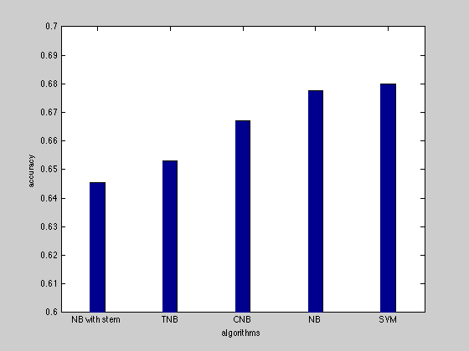

**References**

[1] <http://en.wikipedia.org/wiki/Latent_Dirichlet_allocation>

[2] <http://nlp.stanford.edu/IR-book/html/htmledition/feature-selection-1.html>

[3] Joachims, Thorsten. Text categorization with support vector machines: Learning with

many relevant features. Springer Berlin Heidelberg, 1998.

[4] Yang, Yiming, and Jan O. Pedersen. "A comparative study on feature selection in text

categorization." ICML. Vol. 97. 1997.

[5] Jason D. M. Rennie, Lawrence Shih, Jaime Teevan, David R. Karger “Tackling the Poor Assumptions of Naive Bayes Text Classifiers”

[6] <http://tartarus.org/martin/PorterStemmer/index-old.html>